# Suggested Title: Characterization of Early Cortical Neural Network Development in Multiwell Microelectrode Array Plates?

## Suggested authorship

Ellese Cotterill and Diana Hall (starred joint first), Kathleen Wallace, William R Mundy, Stephen J Eglen, Timothy J Shafer (corresponding).

## Introduction

Microelectrode array (MEA) recordings are a useful tool to study the activity of networks of interconnected neurons, both in vitro and in vivo. In vitro, neural networks on MEAs demonstrate many characteristics of intact neural networks including spiking and bursting activity, pharmacological responsiveness and plasticity (Gross et al., 1997; Potter, 2001; Marom and Shahaf, 2002; van Pelt et al., 2005; Pasquale et al., 2008). Thus, primary cultures on neural networks on MEAs have been widely utilized to study neurophysiology neuropharmacology and mechanisms of action of drugs and chemicals (for review, see Johnstone et al., 2010; others?). In addition, the ontogeny of network activity on microelectrode arrays has been described by numerous different laboratories (van Pelt et al., 2005; Wagenaar et al., 2006; Chiappalone et al., 2006; Illes et al., 2007; Biffi et al., 2013). Until recently, however, the throughput of MEA devices has been limited, such that it was not possible to study more than a small handful (e.g. 4-6) networks at a time.

Recently, two manufacturers of MEA devices have introduced multi-well MEA (mwMEA) devices, which allow for recordings to be made from 12-96 wells simultaneously, with 8-64 electrodes per well. The increase in throughput offered by mwMEA devices expands the capabilities of MEA systems, allowing for drug and toxicant screening (Valdivia et al., 2014; Nicolas et al., 2014) and, in combination with genomic manipulation (MacLaren et al., 2011) or patient-derived inducible pluripotent stem cells (Wainger et al 2014; Woodward et al., 2014), has been used to describe how network function is affected by disease states. Finally, mwMEAs offer the ability to screen large numbers of chemicals for potential effects on developing networks (Robinette et al., 2011; Hogberg et al., 2011). Given the significant public concern over the potential role of chemicals in neurodevelopmental disease states (Landrigan and Grandjean, 2006; 2014), study of chemical effects on neural network ontogeny using mwMEAs offer a functional measure for developmental neurotoxicity hazard characterization.

However, in order for such studies to take place, the basic development of networks on mwMEAs needs to be described in detail. In lower throughput MEA systems, neural network development has been demonstrated to transition from low activity at early developmental ages (e.g. the first week in vitro), to one of coordinated bursting, network spikes and synchrony at later time points (e.g. the second week in vitro and beyond). While it is expected that such properties will be retained in multi-well systems, it remains to be demonstrated, and the time-course, variability and other characteristics defined. Further, while single-well MEAs contain ~60 microelectrodes, only 12 well mwMEA plates have an equivalent number (64/well), and the extent to which network properties can be defined with fewer electrodes has not been determined.

The present studies described the development of networks of mixed primary cortical cultures in 48 well mwMEA plates. These cultures were prepared from newborn rat cortex and contain excitatory and inhibitory neurons as well as glia (Freudenrich and Mundy, 2000). Over the first two weeks in vitro, the neurons extend axons and dendrites (Harrill et al., 2013), form synapses (Harrill et al., 2011) and, in single well MEA systems, develop spontaneous network activity (Robinette et al., 2011). The present studies characterized the ontogeny of activity of these cultures in mwMEAs by describing the firing, bursting, synchrony and network spike properties over the first 12 days in vitro (DIV).

## Methods

### Experimental Protocol

Cell Culture. All procedures using animals were approved by the National Health and Environmental Effects Laboratory Institutional Animal Use and Care Committee. Primary cultures were prepared from the cortex of rat pups as described previously (Mundy and Fruedenrich, 2000; Valdivia et al., 2014). Cells were plated (1.5 x 105 cells in a 25 µl drop of media) onto the surface of 48 well MEA plates that had been pre-coated with polyethylenimine (PEI) as previously described (Valdivia et al., 2014).

MEA Recordings.

Spontaneous network activity was recorded using Axion Biosystems Maestro 768 channel amplifier and Axion Integrated Studios (AxIS) v1.9 (or later) software. The amplifier recorded from all channels simultaneously using a gain of 1200x and a sampling rate of 12.5 kHz/channel. After passing the signal through a Butterworth band-pass filter (300-5000 Hz) on-line spike detection (threshold = 8x rms noise on each channel) was done with the AxIS adaptive spike detector. On days in vitro (DIV) 5, 7, 9, and 12, plates were placed into the Maestro amplifier and allowed 5 min to equilibrate, after which 15 min of activity was recorded. All recordings were conducted at 37 °C, and since development of activity was being studied, there were no *a priori* thresholds for minimum numbers of active electrodes for inclusion of a well in the data set.

### Data

Recordings were made from 656 wells across 16 MEA plates from 15 primary cortical cultures at DIV 5, 7, 9 and 12. The vast majority of these plates were used on or around DIV 14 for other experiments in the Shafer laboratory. A recording of one plate at DIV 12 was missing from our data set, and one recording at DIV 7 was also excluded from the analysis as its very high firing rate suggested that it was an erroneous recording. This resulted in a total of 62 plate recordings, with a total of 2976 well recordings, used in our analysis. As there was some variability in the length of the recordings, only the last 15 minutes of each recording was included in the analysis. Features were extracted in R programming environment v. 3.0 using two open source R-packages, JEMEA and MEADQ. Features related to spikes, bursts, network spikes (Eytan and Marom, 2006), synchrony (Cutts and Eglen, 2014) and theta bursting (Buzsaki G., 2002) were extracted and compiled into a well level data set. Recordings converted into HDF5 file format (Eglen et al., 2014), scripts to generate the features and related R-objects are stored in public repository hosted by github. The goal of establishing a public data set is to allow full reproducibility of our analysis.

### Developmental Analysis

Twelve features were chosen to describe the culture activity, which are summarized in Table 1. For all features, the plate value was taken as the median of all well values on the plate.

Table : Features used in our analysis and a brief description of how they were calculated.

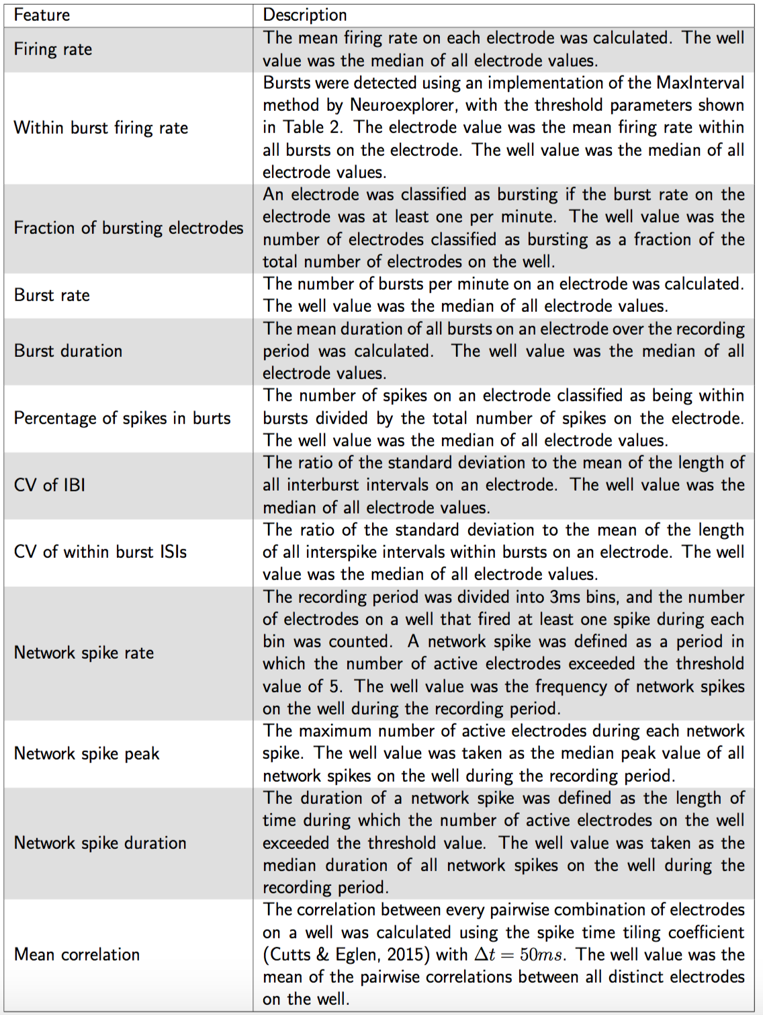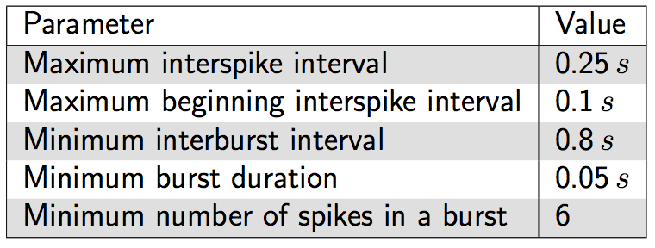

Table 2: MaxInterval method parameters

### PCA

We performed principal component analysis using the R-package FactoMineR using all wells and all 12 features. Two PCA were performed. The first PCA was run on data in which a well constituted one observation, while the second PCA was run on data in which a plate average constituted an observation. For each PCA, the 12 dimensional feature vector was projected down onto the plane created by the first two principal component dimensions. The purpose of the projection was to visually assess the level of differentiation among the 4 ages. A scree plot was made to describe the cumulative percent of variation explained by the use of additional principal components to describe the data. The scree plots aids in quantifying the extent to which data may be well represented with fewer dimensional.

### Classification

Two classification techniques, random forests and Support Vector Machines (SVMs), were used to predict the age of each well based on the twelve features used in our analysis. In some cases, due to the low number of electrodes on a well, lack of bursting or lack of network spike behaviour, some feature values were missing; this was particularly evident at early DIV. For classification purposes, for those wells with no bursts, the within burst firing rate and burst duration were set to zero. Similarly, the network spike peak and duration were set to zero for all wells that exhibited no network spikes over the recording period. Any wells that had null values for the remaining features, namely correlation, CV of IBI and CV of within burst ISI, were excluded from the classification. This resulted in 370 wells, or approximately 12.4% of the total wells, being excluded from the classification.

Initially, classification was performed on the remaining data using a random forest model and all twelve features. The relative importance of each of the features was determined based on the amount they reduced the Gini index. Secondly, Support Vector Machines with a radial kernel and gamma value of 1/12 were used to examine the classification accuracy obtained by using various subsets of the total twelve features.

In both types of classification, two thirds of the data were used as a training set and the remaining third used to test the classification accuracy of the model. The classification was repeated one hundred times using random choices of the training and test sets in each iteration, and the classification accuracy averaged over the one hundred repetitions.

## Results

**Developmental Profile**

Spontaneous activity in the cultured neurons arose and could be reliably recorded from DIV 5 (Figure 1). There was a general trend of increasing activity over development, and in particular an increase in spiking arranged in bursts, as well as correlated behaviour across the network (Figure 1). Quantification of the changes in behaviour over development was achieved using a selection of twelve measures, which were used to describe both well-level and single electrode behaviour.

*Firing rate*

In general, activity increased over development, with the median firing rate and within-burst firing rates both monotonically rising with increasing DIV (Figure 2).

*Bursting behaviour*

A strong trend of increasing bursting behaviour with increasing culture age was also observed. The proportion of electrodes exhibiting bursting behaviour, frequency of bursting and percentage of spikes occurring within bursts were all seen to increase over development (Figure 3). The CV of inter-burst intervals (IBIs) and within burst inter-spike intervals (ISIs) also increased with development, indicating a decrease in the regularity of these features (Figure 3).

*Synchronous behaviour*

The synchrony of activity within each individual well on a plate was examined using a feature called network spikes. Network spikes were defined as short time intervals in which the number of active electrodes on the well exceeded a threshold value, and their frequency, duration and peak number of active electrodes were quantified for each plate (Figure 4). The frequency of network spikes showed a tendency to increase with increasing developmental age. To a lesser extent, an increase in the maximum number of electrodes active during a network spike (out of a possible 16) was also observed across development.

As another measure of network synchrony, we calculated the mean of all pairwise correlation coefficients for all electrodes on a well, using the spike time tiling coefficient (Cutts and Eglen, 2014). Correlations were seen to have a tendency to strengthen over development, particularly at early ages (Figure 4).

Macintosh HD:Users:Ellese:Work:PhD:EPA:Paper_draft:fr_epa.pdf

Figure 1: Example raster plot from one well over the four DIV studied. Each row represents the spike train from one electrode. The scale bar for all raster plots is 60s.



Figure 1

Figure 2: **A** Firing rate, and **B** within burst firing rate..

Figure 2



Figure 3: **A** Fraction of bursting electrodes, **B** bursts per minute, **C** burst duration, **D** percentage of spikes in bursts, **E** CV of IBI, and **F** CV of within burst ISI



Figure : **A** Network spike rate, **B** network spike peak, **C** network spike duration, and **D** mean correlation

**Macintosh HD:Users:dh2744:Dropbox:HistoricOntogenyAnalysis:Analysis:4_in_1.pdf**

Figure 5: [Top left] Well-level PCA projection of 12-dimensional feature vectors onto PC dimension 1 (x-axis) and 2 (y-axis). Each dot represents a well, colored by day in vitro (DIV) of recording. Rough ordering from youngest (lightest, DIV 5) to oldest (darkest, DIV 12) wells is apparent in darkening of colors along the positive direction . (Top right) Scree plot displays % variance explained by the number of PC dimensions. [Bottom left] Plate-level PCA projection of plate averages onto PC dimension 1 (x-axis) and 2 (y-axis). As in top, rough ordering of observations by DIV is apparent in the light to dark transition along the x-axis. (Bottom right) Scree plot of plate-level PCA. Compared to the well-level PCA scree plot, a larger amount of variation is captured in the first two PC dimensions indicating that well averaging reduces variability.

**PCA**

A PCA was undertaken to visualize the level of differentiation among the four culture ages. The wells projected onto the first two PC dimensions show a stochastic organization starting from the earliest age (lightest color, DIV 5) progressing through to the oldest age (darkest, DIV 12). The progression is roughly aligned with the first PC dimension, which accounts for nearly 50% of the variation. This means that the principal mode of variation corresponds to the difference in ages of the cultures. Another salient aspect of the PC projection is that variation appears smaller at earlier ages. Similarly, the projection of the plate averages onto the first two PC dimensions yields a rough segregation by DIV. As in the well-level PCA, the plate average DIVs are aligned with the first PC dimension revealing consistent age related characteristic to the data. A greater percentage of variability is captured by the first PC dimension (67%) as compared with the well-level PCA related to the fact that taking averages reduces well to well variability. Both PCAs display sufficient visual differentiation between observations by DIV that a more thorough quantification of this separation is warranted through classification techniques.

**Classification**

Classification techniques were used to determine the degree to which the recordings could be separated into their ages using the features specified above. Firstly, a random forest model was built and used to predict the age of each well, using the twelve features from our analysis. The model was built using two-thirds of the data as a training set and its accuracy determined by using the remaining one-third of the data as a test set. When used to predict the age of each well from the four possible ages, the accuracy of the random forest model, averaged over one hundred trails, was approximately 72% (compared to the 25% accuracy that could be expected by chance).

From these random forest models, we were also able to determine the relative importance of each of the features in driving the classification (Figure 6). The two most important features were those measuring coefficients of variation, namely the CV of within burst ISI and CV of IBI. In our developmental analysis, these two features both exhibited a monotonically increasing trend with age.

Next, we used Support Vector Machines (SVMs) to quantify the degree to which recordings could be classified correctly by age when only a subset of our features was used. The SVM classifier, built using the same proportion of training and test sets specified above, had a slightly higher level of accuracy, of approximately 75.6%, compared to the random forest model using all twelve features. By removing each feature from consideration in order of their increasing importance, we could examine the classification accuracy as the number of features was varied. In general we found that the classification accuracy remained high as the number of features was reduced, however, at least three or four features were required to maintain a reasonable level of prediction accuracy (Table 3).

We used a similar method to examine the extent to which each pair of ages of arrays could be separated using classification techniques. In this case, rather than using all of the data in the classification, the SVM classifier was built separately on each pairwise combination of ages. The classifier was most accurate in distinguishing arrays with large differences in age, for example DIV 5 and DIV 12 arrays, for which only the top feature, CV of within burst ISI, was required to achieve almost 93% prediction accuracy (Table 4). Classification performance was poorest for pairs of arrays in which the age difference was low. For example, the prediction accuracy for distinguishing DIV 9 from DIV 12 arrays was only just above chance when using one feature, and never exceeded 86% when using any combination of features (Table 4).

Figure 6: Average importance of features in driving classification, relative to the most important feature.

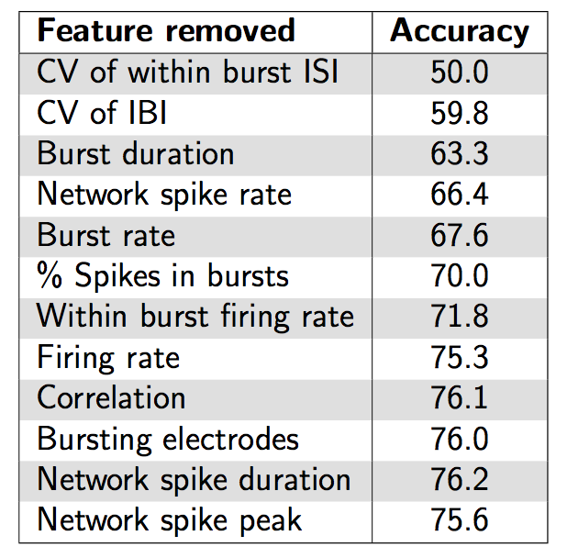

Table 3: Classifier performance at predicting the age of arrays. Features are listed in decreasing order of importance, and the value in each row n=1,...,12 is the mean percentage of correct classifications using the top n features.

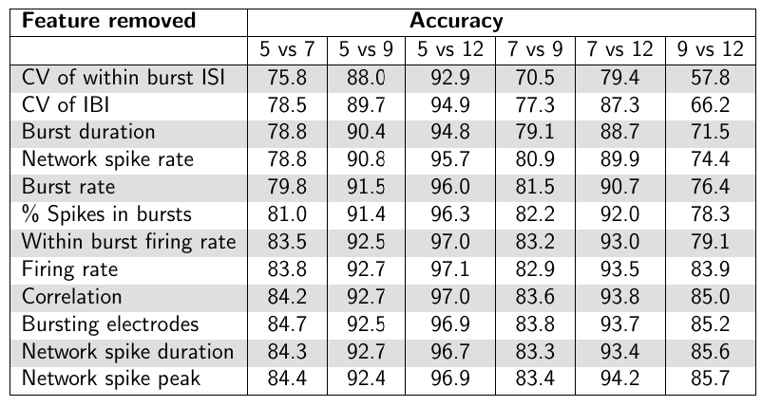

Table 4: Classifier performance at predicting the age of arrays for each pairwise combination of DIV. Features are listed in decreasing order of importance, and the value in each row n=1,...,12 is the mean percentage of correct classifications using the top n features.

## Discussion

The present results describe the ontogeny of network activity in 48 well MEA plates during the first 12 days in vitro. The results demonstrated a rapid ontogeny of spiking, bursting synchrony and network spiking activity over this period of time. This ontogeny is similar to the ontogeny of activity in single well MEAs. Furthermore, principle components analysis and classification methods can be used as reliable predictors of network age. These results demonstrate the neural network ontogeny on mwMEAs offers, relative to single well systems, a high-throughput approach to study network development and its perturbation by drugs, chemicals and disease.

Previous studies of cortical and hippocampal network ontogeny have demonstrated that activity begins with random, single spiking activity on a single or few channels, and over a period of 2-3 weeks in vitro progresses to bursting activity which becomes more synchronous with time (van Pelt et al., 2005; Wagenaar et al., 2006; Chiappalone et al., 2006; Illes et al., 2007; Biffi et al., 2013). This is accompanied over time by the emergence of network bursts. We observed a similar ontogeny of activity in the present experiments; however, similar to previous data with this culture model (Robinette et al., 2011), the ontogeny of spiking and bursting activity occurred rapidly within the first two weeks in vitro, specifically between DIV 5 and 12 in the present study. One reason underlying the relatively more rapid ontogeny of activity in the present experiments may be the use of a culture made from early postnatal (0-24hr) rats, as opposed to other reports where embryonic (E14-E18) preparations were utilized. Another factor that may contribute to the rate of the ontogeny of activity may be the use of relatively higher culture densities, which has been shown to influence the rate and patterns of ontogeny of neural networks (Wagenaar et al., 2006; Biffi et al., 2013). In any event, the ontogeny of activity in networks cultured on mwMEA plates was qualitatively similar to that on single well plates (as expected). Furthermore, it appears that this network ontogeny can be adequately described using as few as 16 electrodes in a well.

The use of classification techniques such as RFA and SVM indicated that the parameters extracted from the spike trains in these experiments could be used to reliably predict the age of the culture from which data were obtained. While the models performed best when all of the parameters were used to aid classification, several parameters had greater influence on the ability to predict culture age. These included the CV of within burst ISI, the CV of the IBI, mean burst duration, network spike rate and burst rate.

How to intepret results (e.g. is DIV 5 easy to classify because of absence of network spikes at that age -- cf with onset of synaptogenesis around DIV 7).

Implications for toxicology testing: which features to focus on if you must choose only one or two features ("1990s approach") versus using our classification framework to find the best features in an unbiased manner.

Handling of multi-well arrays: how best to use the wells to record from cultures (e.g. should all wells record cells taken from the same animal?)

## References

Buzsaki G. (2002) Theta oscillations in the hippocampus. Neuron. 33:325-40.

Charlesworth P et. al. (2015) “Quantitative differences in developmental profiles of spontaneous activity in cortical and hippocampal cultures” Neural Dev.

Cutts and Eglen (2014) “Detecting pairwise correlations in spike trains: an objective comparison of methods and application to the study of retinal waves” J. Neuroscience 34(43): 14288-303

Eglen SK, Weeks M, Jessop M, Simonotto J, Jackson T, Sernagor E. A data repository and analysis framework for spontaneous neuronal activity recordings in developing retina. Gigascience. 2014;3:3

Eytan and Marom (2006) “Dynamics and Effective Topology Underlying Synchronization in Networks of Cortical Neurons“, J. Neuroscience, 26, 8465-8476.

Grandjean P, Landrigan PJ. Developmental neurotoxicity of industrial chemicals. Lancet. 2006 368, 2167-78.

Grandjean P, Landrigan PJ. Neurobehavioural effects of developmental toxicity. Lancet Neurol. 2014. 13, 330-8.

Harrill JA, Robinette BL, Freudenrich T, Mundy WR. Use of high content image analyses to detect chemical-mediated effects on neurite sub-populations in primary rat cortical neurons. Neurotoxicology. 2013 34, 61-73.

Harrill JA, Robinette BL, Mundy WR. Use of high content image analysis to detect chemical-induced changes in synaptogenesis in vitro. Toxicol In Vitro. 2011 25, 368-87.

MacLaren EJ, Charlesworth P, Coba MP and Grant SGN. Knockdown of mental disorder susceptibility genes disrupts neuronal network physiology *in vitro*. Mol Cell Neurosci 2011. 47, 93-9.

Nam Y, and Wheeler BC. In vitro microelectrode array technology and neural recordings. Crit Rev Biomed Eng 2011. 39, 45-62.

Nicolas J, Hendriksen PJ, van Kleef RG, de Groot A, Bovee TF, Rietjens IM, Westerink RH. Detection of marine neurotoxins in food safety testing using a multielectrode array. Mol Nutr Food Res. 2014. 58, 2369-78.

EPAmeadev [http://github.com/sje30/g2chvc]

R Core Team. R: A Language and Environment for Statistical Computing. Vienna, Austria; 2014. [http://www.r-project.org]

Robinette BL, Harrill JA, Mundy WR, Shafer TJ. In vitro assessment of developmental neurotoxicity: use of microelectrode arrays to measure functional changes in neuronal network ontogeny. Front Neuroeng. 2011. 4:1.

Valdivia P, Martin MT, Houck K, Lefew WR, Ross J and Shafer TJ. Multi-well microelectrode array recordings detect neuroactivity of ToxCast compounds. Neurotoxicology 2014. 44, 204–17.

Wainger B et al. Intrinsic Membrane Hyperexcitability of Amyotrophic Lateral Sclerosis Patient-Derived Motor Neurons. Cell Reports 2014. 7, 1–11

Woodard et al., iPSC-Derived Dopamine Neurons Reveal Differences between Monozygotic Twins Discordant for

Parkinson’s Disease, Cell Reports (2014), http://dx.doi.org/10.1016/j.celrep.2014.10.023